Database establish connection error on website

Client Name: Linda Augustine
Client Website: ayearatthetable.com
Error Code with Screenshot: Error establishing data base connection
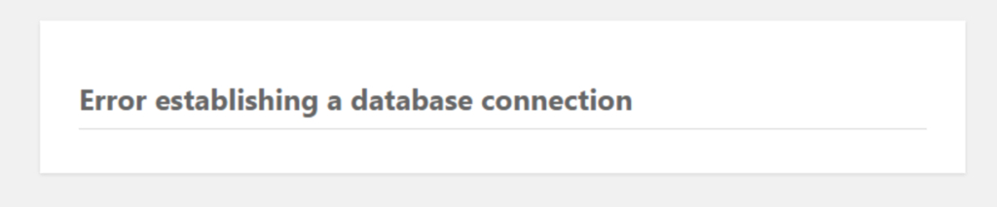

- Overview: The “Error Establishing a Database Connection” is a message that appears when WordPress cannot connect to the database.

Originally, WordPress is written in PHP and uses MySQL as its database system. When someone visits your site, specific PHP commands will fetch your site information from the database, which will then be displayed on the visitor’s browser.

Since there is no data to retrieve and display on the browser, the WordPress “Error establishing a database connection” message will pop up on a blank page.

- Challenge to troubleshoot the issue: On a day Linda notified us on email that they are unable to access the ayearatthetable.com website. Then after our debugging, we found that the website is displaying a "Database Connection Error" message. This error code shows a failure in establishing a connection between the website and the database server. This was the challenge faced in identifying the cause of the error and restoring the website functionality.
- Solutions to fix the issue: Here are few things we can include in fixing the database connection error,

A. Make Sure Your Domain Is Pointing to Your Host Provider: This error is a common error when you are migrating a site from one server to another hosting server because switching to a new hosting provider will automatically move your files to the new host. However, if your domain is not pointing to your host where the database is hosted, it will cause database failure. In that case start checking the nameservers if they are connecting to your new hosting server where you have the correct files and connectivity.

B. Check Your Database Server: A database connection can also come when the MySql server is down because it has a maximum capacity set in the backside of server, when it reaches its maximum limits, that time your MySql server is unable to handle the requests and it shows a " Error Establish a database connection "
C. Check the Database Login Credentials: The most common reason for the WordPress “Error Establishing a Database Connection” message is invalid login credentials. Usually, this happens after a WordPress site migration to a different hosting provider.
To fix this problem, check if the database login settings match with the ones stored in your wp-config.php file. You can access this file via an FTP client or the WordPress File Manager in your hosting control panel.This will open a set of database information and configurations. Find and take note of the following data:
DB_NAME – database name
DB_USER – username
DB_PASSWORD – password
DB_HOST – database host
See the screenshot below:

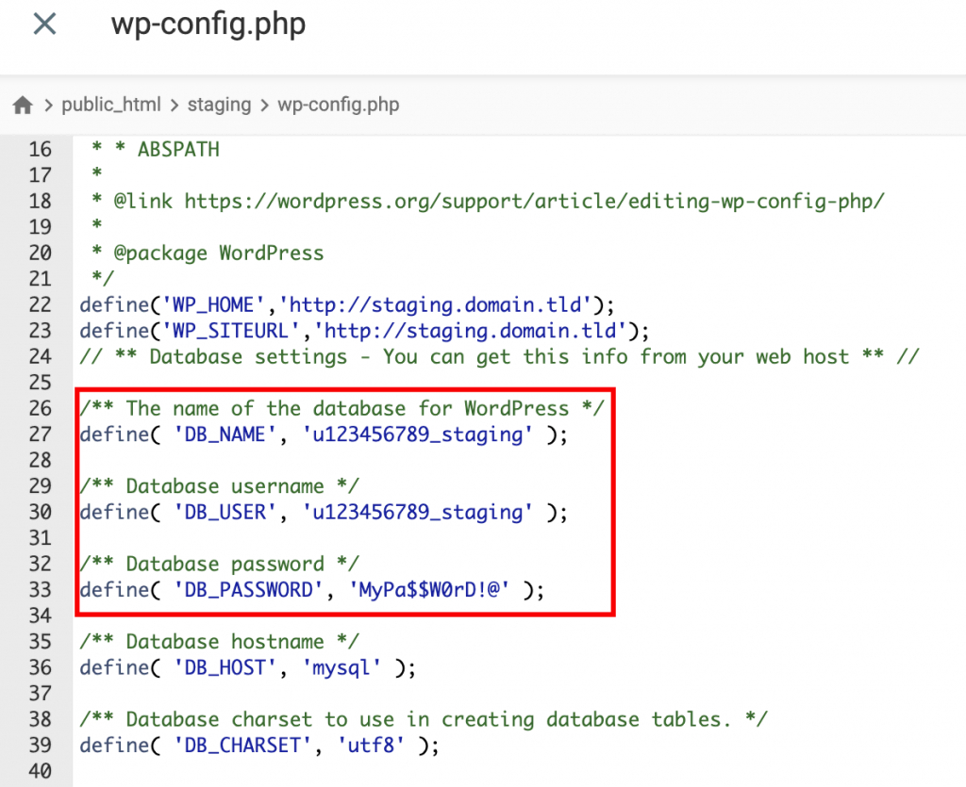

After this you need to check the login credentials are correct or not, if you are not sure about the details, you can reset it from your hosting Cpanel. And then write the correct details in your wp-config.php file.

D. Fix the Corrupted Files: Besides from corrupted database, this corrupted files can also be the reason of this error. You need to check your themes and plugins to be sure.
To identify which component is causing the error, check them separately. Your theme might be the problem if the error happens after activating a new one.
To resolve this problem, navigate to Appearance → Themes on your WordPress dashboard and then switch to another theme.
If changing the theme doesn’t fix the “Error Establishing a Database Connection” problem, it might come from a corrupted plugin. In this case, try disabling all of your plugins and enabling them one by one to find the culprit.

Alternatively, you can deactivate all WordPress plugins by renaming the corresponding folder from your hosting control panel. Here’s how to do so.

E. Repair the Database in WordPress: Another reason that may show the “Error Establishing a Database Connection” in WordPress is a corrupted database. This can be caused by data failure from plugins or themes that are regularly added or removed.
You might have a corrupted database if your WordPress dashboard shows a message along the lines of “One or more database tables are unavailable. The database may need to be repaired.”
You can easily fix this problem by inserting the following function into the bottom of your wp-config.php file:
define('WP_ALLOW_REPAIR', true);

- Conclusion: After doing a tough investigation and debugging, like doing the database repair, database connection check or disabling the theme and plugin, we successfully able to fix the problem. There was an error which was related to the login credentials of the database were incorrect in the wp-config.php.

